
Year 11 ATAR Chemistry
Task 2: Atomic Structure & Bonding Test
Weighting: 5% of Year Grade
NAME: ______________________________
TEACHER’S NAME: ___________________
Required Resources:
Blue or Black pen, Ruler, Calculator, Chemistry Data Book
Not Allowed:
Notes, Personal Periodic Tables
SECTION | NUMBER OF QUESTIONS | AVAILABLE MARKS | MARK
Multiple Choice | 10 | 10
Short Answer | 18 | 50

SECTION A: MULTIPLE CHOICE SECTION (10 marks)
INSTRUCTIONS
For each question, shade the box to indicate your answer. Use only a blue or black pen to shade the boxes. For example, is b is your answer:

If you make a mistake, place a cross through the square and shade your new answer, for example d:


If you then want to use your first answer b, cross out d and circle b:

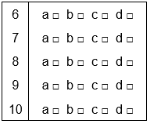
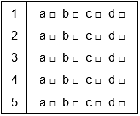
- The following diagram shows the first five ionisation energies of element X.
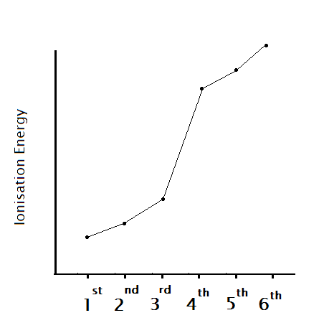
Element X has how many valence electrons?
- 4
- 3
- 8
- 1
- Which separation technique is most useful for separating a mixture of two liquids with differing boiling points?
- Filtration and evaporation
- Distillation
- Gravity separation
- Centrifugation
- Carbon atoms exist in nature with mass numbers 12, 13 and 14. Which one of the following is an incorrect statement?
- The different carbon atoms in nature are called isotopes.
- All of the carbon atoms in nature have the same number of neutrons in the nucleus.
- All the isotopes of carbon in nature have identical chemical properties.
- All of the carbon atoms in nature have the same number of protons in the nucleus.
- The combination of the aluminium ion and the sulfate ion can be represented by the ionic formula:
- Al₂(SO₃)₃
- Al₃(SO₄)₂
- Al₂(SO₄)₃
- Al₃(SO₃)₂
- The purpose of a photomultiplier tube in an atomic absorption spectrometer is to:
  - Produce a beam of light with a wavelength specific to an element.
  - Focusses the beam of light passing through the flame into the detector.
  - Detect light that is transmitted through the flame.
  - Inject the sample solution into the burner slit.

Questions 6 and 7 relate to the following table:
Element | No. protons | Electron configuration | Type of element
Calcium | A | (2,8,8,2) | B
Arsenic | 33 | C | Metalloid
Argon | D | (2,8,8) | E

- What is represented by the letter B?
  - Transition metal
  - Rare earth element
  - Alkali metal
  - Alkaline earth metal
- How many valence electrons are there in an atom of arsenic?
  - 7
  - 5
  - 3
  - 6
- Which of the following pairs are structural isomers?
- benzene and cyclohexane
- but- 1-ene and cyclobutane
- dichloromethane and trichloromethane
- 2, 3-dimethylbutane and pentane
- Which is the best definition of the term ‘electrostatic force’?
  - The attractive or repulsive forces between charged particles.
  - The force that hold the nuclear particles together.
  - The force that neutrons exert on protons in the nucleus.
  - The affinity that an atom has for electrons.
- A molecule of a non-cyclic alkane contains 7 carbon atoms. The number of hydrogen atoms in this molecule is:
  - 7
  - 14
  - 16
  - 28

SECTION B: SHORT ANSWER SECTION (50 marks)
- What is meant by the following terms:
  - Electronegativity:

  - First ionisation energy:
(2 marks)

- The following graph shows the trend in first ionisation energy from neon to argon.

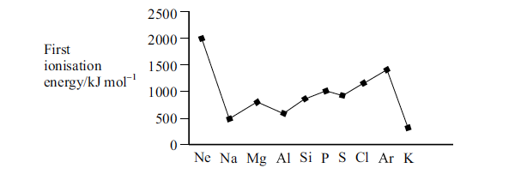

Explain the gradual increase in first ionisation energy from sodium to argon.
(2 marks)

- Calculate the number of subatomic particles in the following atoms:

Element symbol: | No. of protons: | No. of neutrons: | No. of electrons:
Al³⁺
Zn-68
(6 marks)

- The following diagram shows the mass spectrum for the isotopes of tin (Sn).

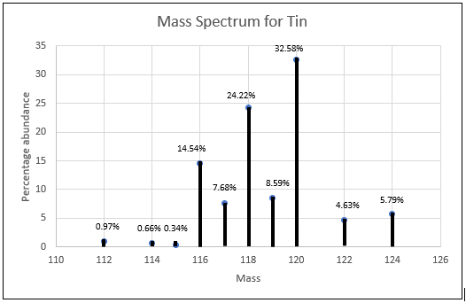

Calculate the relative atomic mass of tin, showing all workings. (2 marks)

- Draw the electron structure and write the electron configuration for the following atoms:

CALCIUM | PHOSPHORUS
(4 marks)
- Explain the trend of atomic radius across a period of the Periodic Table.
(3 marks)
- In regard to the element fluorine, explain why it is more electronegative than chlorine.
(2 marks)

- Label the following parts of an atomic absorption spectrophotometer.
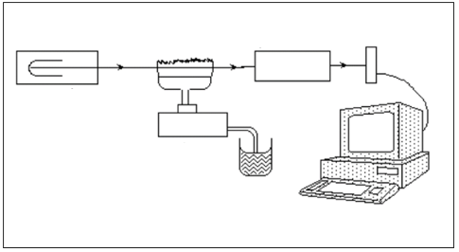
3.
1.
2.
(3 marks)
- From the following pairs of anions and cations, write down the formula for the ionic compound produced:

Cation: | Anion: | Formula for ionic compound:
Magnesium | Nitride
Ammonium | Carbonate
(2 marks)

- Explain, referencing the structure of the substance, why potassium bromide crystals do not conduct electricity, but a solution of potassium bromide can.
(2 marks)

- Identify A, B, C, D and E as one of the following.

diamond lead ethanol sodium chloride.
Substances | State at room temperature | Conductivity in solid | Conductivity in molten/liquid | Dissolves in Water
A | Solid | No | Yes | Yes
B | Liquid | No | No | Yes
C | Solid | No | No | No
D | Solid | Yes | Yes | No

Name
A
B
C
D
(4 marks)
- Write chemical equations for the following hydrocarbon reactions. Structural formula should be used to represent hydrocarbons.
Benzene reacting with chlorine gas in the presence of an AlCl₃ catalyst: (2 marks)
Propene reacting with bromine water. (2 marks)

- Draw the following cis/ trans isomers of the following compounds.
Compound: | Cis isomer | Trans isomer
But-2-ene (2-butene)
1,2,-dichloroethene
(4 marks)
- Write the name for the following hydrocarbons.
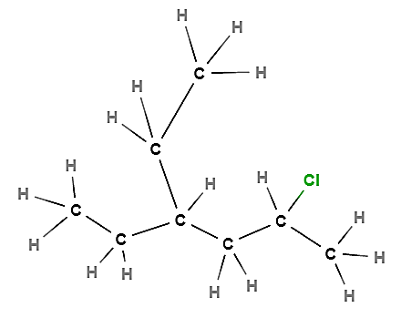 | 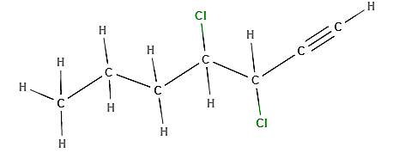
(2 marks)
- Draw the structural formulae for:
3-ethylcyclobutene | 3-bromo-2-methylpent-1-ene
(2 marks)
- What are the two requirements for a molecule to be polar?
1.
2.
(2 marks)
- Explain why metals are able to conduct electricity.
(2 marks)
- Aluminium can be produced by the caustic leaching of bauxite by concentrated sodium hydroxide solution, careful precipitation of aluminium oxide (Al₂O₃) and smelting in a high temperature furnace. What mass of bauxite which is 36.8% aluminium in composition is needed to produce 5.00 kilograms of aluminium metal? (2 marks)

END OF TEST

